Chapter 2

Chester Moody Summitt (1931-2009)

Chester Moody SUMMITT was my dad. He was born on September 9, 1931, in Cardwell, Missouri. His father, Chester, was 44 and his mother, Katie, was 40. Dad was the second youngest of nine siblings. The same year that dad was born the Empire State Building opened in New York City and the Japanese invaded Manchuria. In 1933, Franklin D. Roosevelt was elected President and proposed the “New Deal” in response to the Great Depression. Chicago Mayor Anton Cermak was killed by Giuseppe Zangara, an anti-capitalist Italian naturalized U.S. citizen, during an attempted assassination of the president-elect seventeen days before Roosevelt’s inauguration. The year also saw the passage of the 20th Amendment to the U.S. Constitution which set the beginning and ending of the terms of the elected federal offices, and the 21st Amendment which ended Prohibition.
On Aug 23, 1934, when Moody, as Dad came to be known, was two years old, his younger sister, Alice Lucretia, was born. Earlier that year, John Dillinger was killed and the Dust Bowl began brought on by poor farming methods, heat waves, and severe drought, among other causes. The following year the F.B.I. was established with J. Edgar Hoover as director, Huey Long was assassinated, and Social Security became law.
Alice Lucretia died on February 9, 1935, in Cardwell, Missouri, when Dad was 3 years old. According to her death certificate, as shown below, Alice died around four in the morning on the ninth. Primary cause of death is listed as bronchopneumonia with other contributing causes listed as encephalitus.
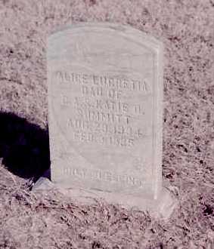Photograph 1: Headstone of Alice Lucretia Summitt, Cardwell Cemetary

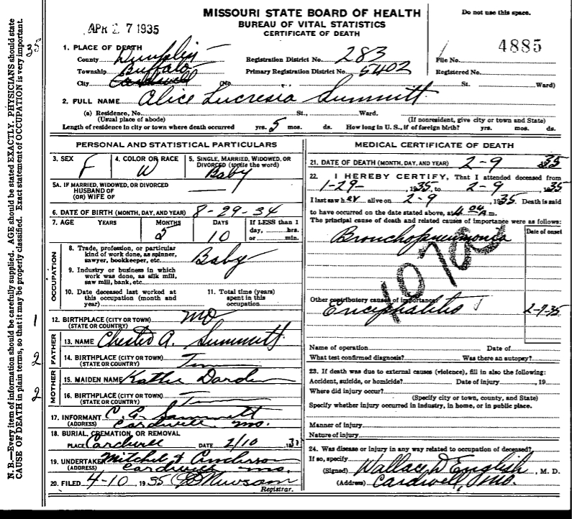
The death certificate is signed by Wallace D. English, M.D. of Cardwell, Missouri, and the undertakers are listed as Mitchell & Anderson of Cardwell, Missouri. The following obituary and thanks were published in the Dunklin Democrat.
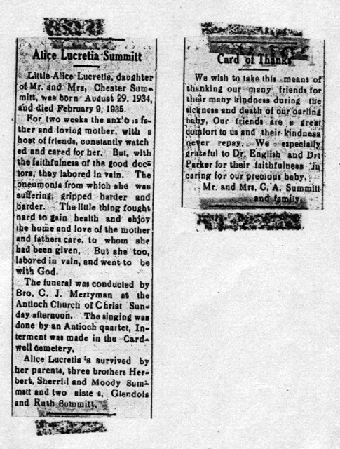
The year 1936 saw Roosevelt elected to his second term. The following year 35 people died in the Hindenburg disaster, the United States Navy gunboat USS Panay was attacked by the Japanese while anchored in the Yangtze River outside of Nanjing, and the Golden Gate Bridge opened in San Francisco.
Dad told me a story one time about a flood that covered the entire area around Cardwell. He was only old enough to have a tricycle so I’m guessing the flood he was talking about was the Great Flood of the Ohio and Mississippi Rivers from January through February 1937. My grandfather, Chester Alba (known as Papa), owned a house that sat on the highest point of ground in the area so, according to Dad, everyone took refuge at Papa’s house.
In 1938 Superman debuted in Action Comics while Orson Welles scared the country with The War of the Worlds.” Nazi Germany invaded Poland in 1939 while Roosevelt gave the first televised presidential speech at the 1939 New York World’s Fair.
Dad first shows up in the 1940 census in the household of his father, Chester Alby Summitt, in 1940 in Cardwell, Missouri.
Illustration 1: 1940 Census, Cardwell, Missouri
According to the census, C. Moodie was an 8 year-old, single white male at the time of the census. His father, Chester A., was listed as being a fifty-three year old, married, white male, having been born in Tennessee. Moody’s mother, Kattie O., was listed as being a forty-nine year old, married, white female also born in Tennessee. The census lists three older siblings living at home in 1940. Those siblings included two older sisters, Glendola D., a twenty year-old single, white female, and Ruth, a fifteen year-old single white female, and one brother, W. Sherril, a twelve year-old single, white male. All the children are listed as attending school and having been born in Missouri.
The year 1940 saw the U.S. population reach over 132 million people and also saw the first peacetime draft in U. S. History with the Selective Service Act. The Alien Registration Act also became law as the country made it set criminal penalties for advocating the overthrow of the the government by force or violence, and required all non-citizen adult residents to register with the federal government. Roosevelt was elected to a record third term and Bugs Bunny, Tom and Jerry, and Woody Woodpecker made their debuts that year.
In 1941 the United States occupied Iceland to prevent a potential invasion by Nazi Germany. Then on December 7, 1941, Japanese fighter planes attacked Pearl Harbor, Hawaii, at 7:55 a.m. This surprise attack on United States soil, destroyed the U. S. Pacific Fleet docked at the base. The attack, which took the lives of 1,177 sailor and marines, as well as the loss or damage to twenty-one naval ships, and a total of over 2,400 American lives, led to the entry of American troops into World War II. On December 8, 1941, the United States of America declared war on Japan, officially entering World War II. On December 11, 1941, the United States declares war on Germany and Italy, responding to their declaration of war against America. Dad was ten years old and lived in Cardwell, Missouri.
Several historical events took place in 1942. Probably the most appalling, from a human rights perspective, was Executive Order 9066. Roosevelt signed into law an act which confined over 110,000 Japanese Americans, 75,000 of which were American citizens, in detention camps around the country including two in Arkansas. In June of that year the Japanese fleet attacked the Midway Islands While the Japanese suffered a defeat at Midway, they were able to invade the Aleutian Islands which was the first invasion of American territory in 128 years. The Marines landed on Guadalcanal in the Solomon Islands in August becoming the first American offensive of World War II. In November the United States and Great Britain invade North Africa.
February of 1943 saw the United States military suffer its first major defeat in North Africa at the Battle of Kasserine Pass in Tunisia. Race riots broke out in Detroit and Harlem causing forty deaths and seven hundred injuries. In July US forces invaded Sicily beginning the campaign for Axis-controlled Europe. Nine days later, Rome was bombed by Allied forces. In November, the Marines won the battle of Tarawa (also known as Bloody Betio).
June of 1944 brought the start of the battle for Guam in the Pacific as well as the invasion of Normandy, Operation Overlord, in Europe. November saw Roosevelt win a fourth term in office and in December, the U. S. Supreme court stated that it was alright to deprive citizens of their rights in time of war in the case of Korematsu vs the United States.
Dad never spoke too much about what happened locally during the war. He did tell me about how Papa helped him win a iron collection drive for the war effort. The prize was a month’s free admission to the Cardwell Movie Theater. Dad was never allowed to use the prize as Papa said movies were sinful. He did tell me about how, after he and Mom started dating that she would go to the back exit and hold the door open so he could get in without Papa knowing but that would be a few years after the war.
February of 1945 saw Roosevelt, Churchill, and Stalin hold the Yalta Conference where they mapped out the world after the war. February also saw thirty thousand Marines land on Iwo Jima. March saw American troops cross into Germany. April saw in invasion of Okinawa and the death of President Roosevelt. Missouri politician Harry S. Trumann suddenly became President. I don’t know what Dad thought of this but I remember him being a democrat for most of his life. In May, Germany surrendered and in August the first and second atomic bombs where dropped and Japan surrendered. Dad turned 13 in September.
I don’t know when Dad started dating Mom. I have heard the story of Dad taking Mom home on a motorcycle and the road to her house was flooded so Dad had to carry Mom in his arms about a quarter of a mile through the flooded road because Mom had just had an appendectomy. This would have had to been around 1948 probably.
Mom was born Shirley Francis Frie on October 13, 1934 in Cardwell, Missouri, to Carman Lewis Frie and Iva Francis Glasgow Frie. She had two brothers; one older, Ray Lewis; and one younger, Larry Don.
In high school Dad played basketball, was a member of the Future Farmers of America, was in the glee club and chorus, was in the band, and was on the annual staff.
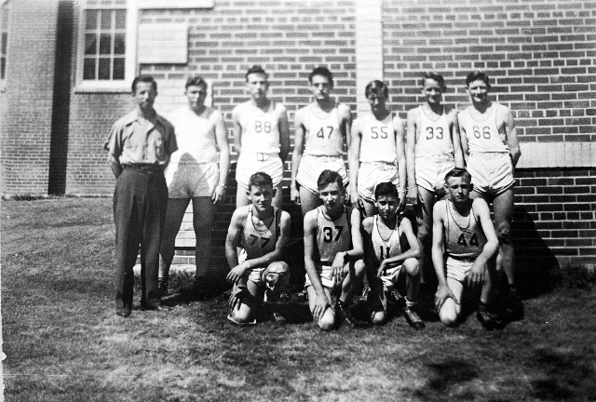Photograph 2: Dad is kneeling, first on the left
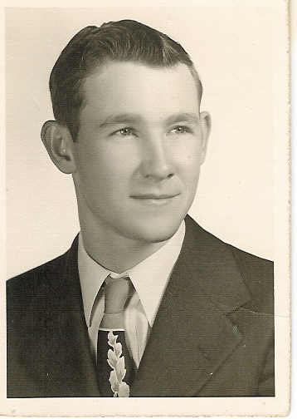
Dad graduated high school in 1950. Also in his senior class, as seen in the class picture on the next page, was his nephew Allison Summitt, his future brother-in-law Ray Lewis Frie, his future sister-in-law Bonnie Wallace, and Mom’s second husband Fred Queen. Dad’s older brother Sherrill, a teacher at Cardwell High School, was one of the senior class sponsors.
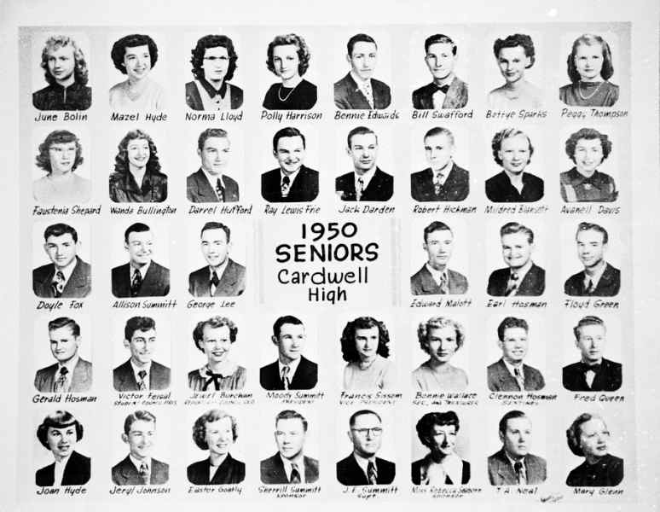
In June of 1950 North Korean forces invaded South Korea and the Korean War began. Mom and Dad got married in Arkansas on September 14, 1950. He had just turned 19 and she would be 15 for another month. They moved into a small house about two miles North of Cardwell. In November of 1950 there was an assassination attempt on President Truman and McCarthyism began. Mom and Dad would live in the house North of Cardwell until Dad joined the Navy on December 1, 1951.
Dad ended up stationed at Kingsville Naval Air Station outside of Kingsville, Texas. Dad was a fireman and put out fires on the runways. The French-Indochina War was going on at the time and Dad said the Vietnamese take-offs were great but their landings were terrible. He said he picked up his share of body parts on more than one occasion. This was while the French were fighting Vietnamese Communists. The United States had some advisers in country but it was still France’s war.
Photograph 3: Dad's Navy Bootcamp Picture
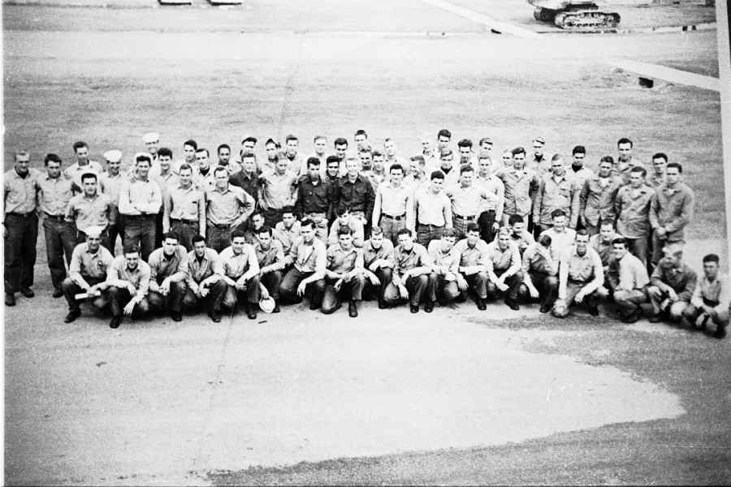
Mom joined Dad in Kingsville shortly after he was stationed there. Having both attended the Church of Christ, they looked for and found a local church there in Kingsville. There they met two couples that would become very important in their lives over the next years. Papa Blackie and Grandma Dessie and Uncle Drayton and Aunt Dot, as I came to now them, became very dear friends and Mom and Dad’s family away from home.
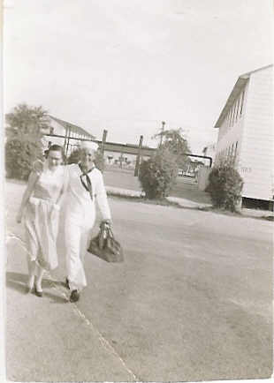Photograph 4: Mom and Dad on the Kingsville NAS
Dad’s mother, Katie Okalona Darden Summitt, passed away in Memphis, Tennessee on October 21, 1953. She was 63. She was born September 11, 1890 in Tennessee. He parents were James K. Darden and Nancy Tucker Darden. She had married my grandfather in Cardwell on February 29, 1908.
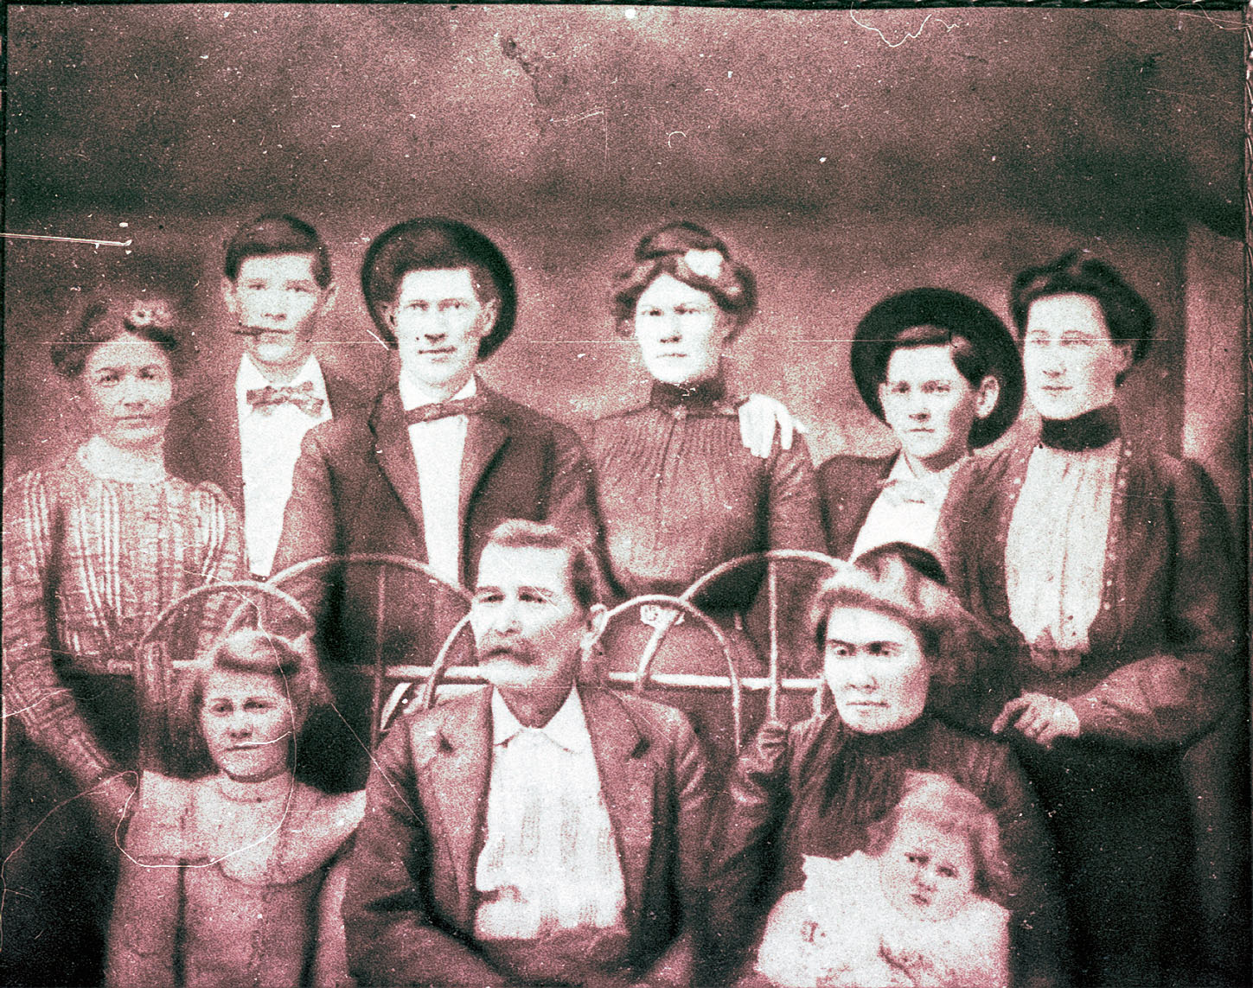Photograph 5: Katie Okalona Darden is on the lower left sitting.
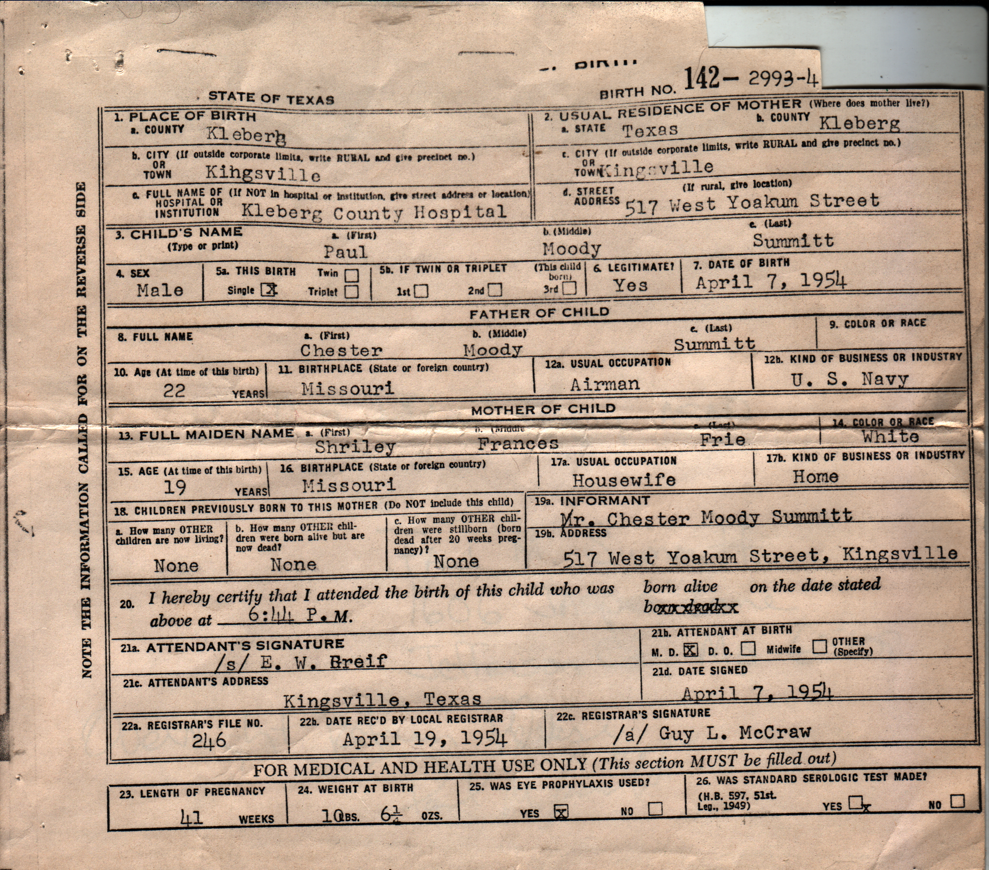
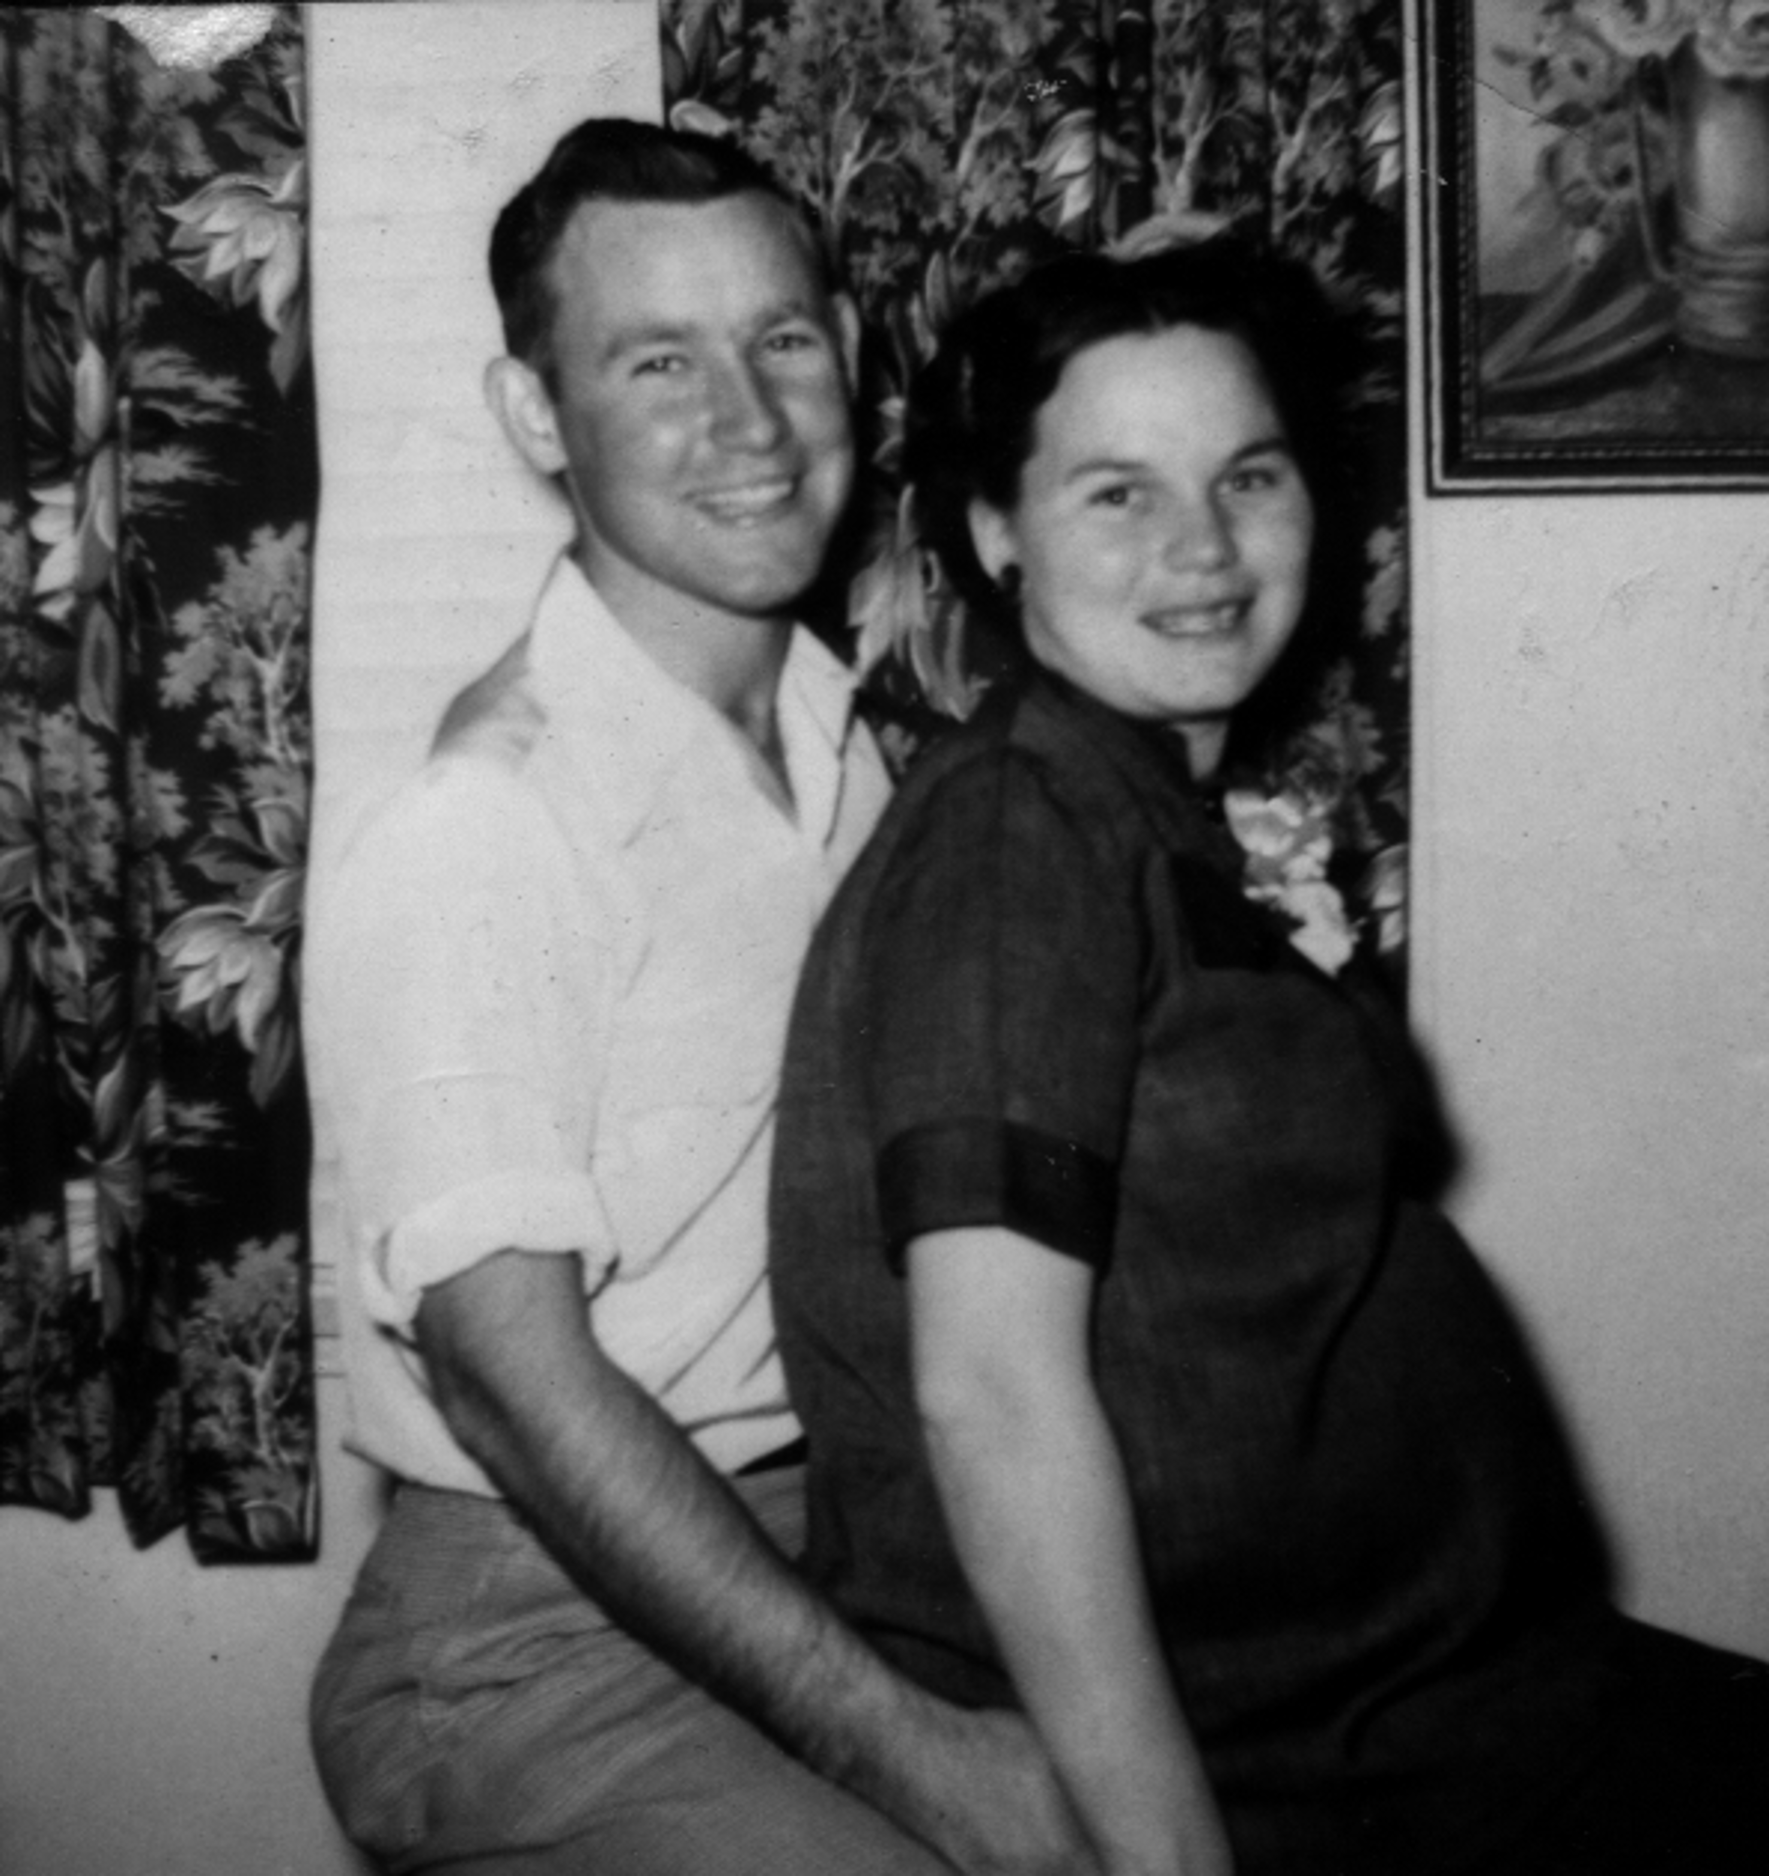
Shortly after that Mom discovered she was pregnant. Mom used to say that I would put my feet on her spine and push out forward with my hands. On April 7, 1954, I was born there in Kingsville, Texas. They named me Paul Moody Summitt. Mom said that she carried me for over ten months and that I was born with a head of hair and a mouth full of teeth. Dad was 22 and mom was 19. Papa and Papaw and Granny and Mom’s brother, my Uncle Larry, all came to Kingsville to see me.
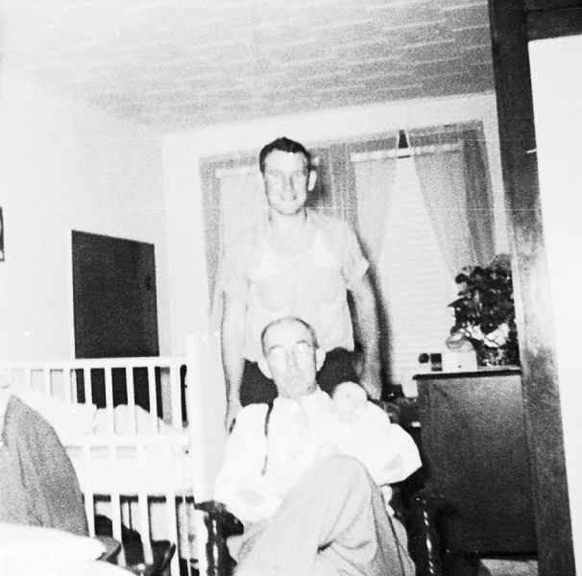Photograph 6: Papa, Dad, and me.
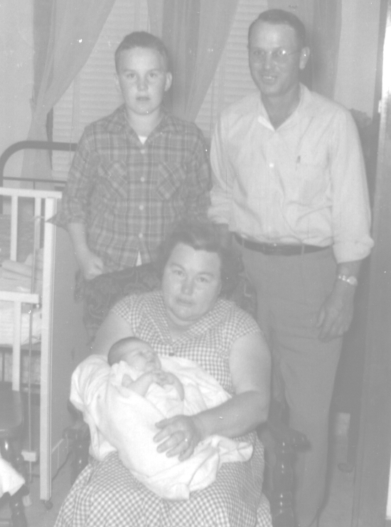Photograph 7: Uncle Larry, Papaw, Granny, and me.

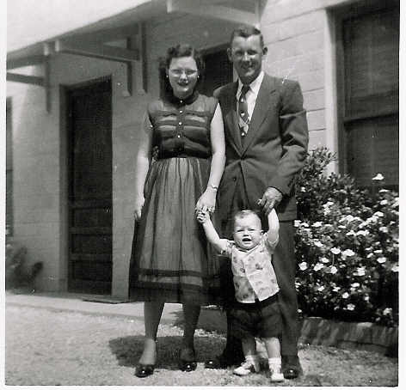Photograph 9: Mom, Dad, and I outside our appartment getting ready for church
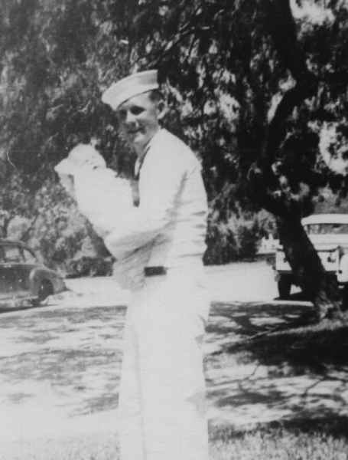Photograph 8: Dad holding me after bringing me home
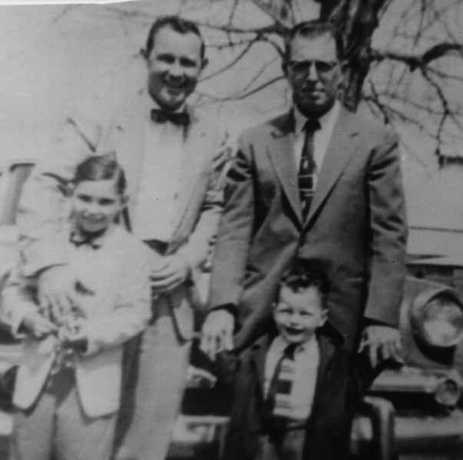Photograph 10: 1957: Dad, Uncle Drayton, Sam, and me
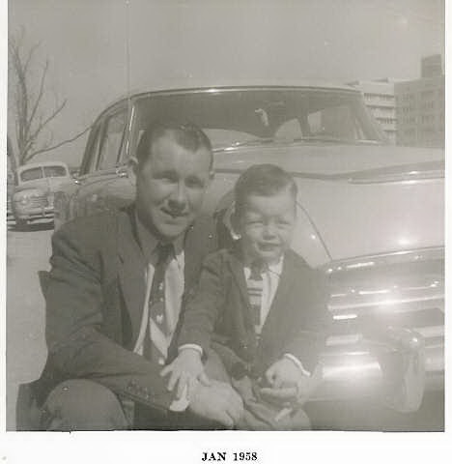Photograph 11: 1958: Dad and me, University of Missouri, Columbia, Missouri
Dad’s enlistment was over November 30, 1955. He entered Arkansas State College and studied agriculture.
Then, some time after 1956, we moved to Columbia, Missouri where he started studying Agriculture at the University of Missouri. We lived in the married housing Quonset huts that were located where the MU football stadium and Hearnes Center is now. Dad took classes in Switzler Hall which was the School of Agriculture at that time. Mom got a job at what was then the Student Health Center and is now Noyes Hall.
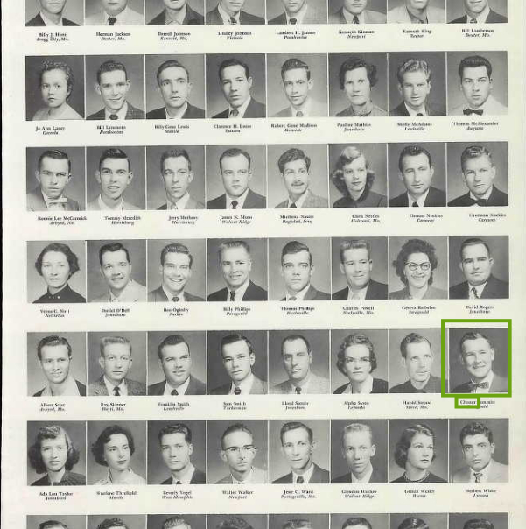Photograph 12: Arkansas State College, 1956
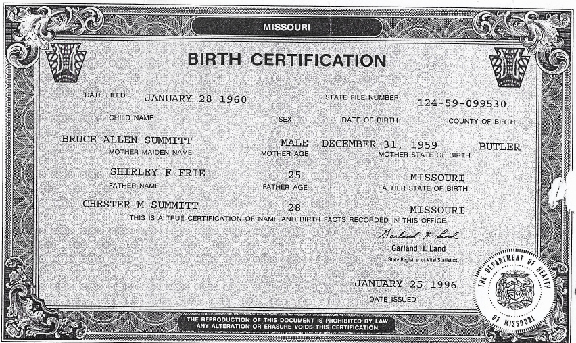
After Dad graduated, he went to work for DeKalb for a while. In 1959 we moved to New Madrid, Missouri and I started Kindergarten. We next moved to Poplar Bluff, Missouri when, I believe, Dad went to work for the Missouri Extension Service as a conservation agent. On December 31, 1959, my little brother, Bruce Allen Summitt, was born. I remember Mom telling me that she had wanted his middle name to be spelled Alan but whoever was writing the information down on the official documents thought her maiden name must have been Allen and that’s why it’s spelled that way. According to her, Dad was at a New Year’s Eve party when Bruce was born. After their divorce there were many stories told to us by her about his alleged infidelity.
We moved to De Soto, Missouri around 1963. Dad was still with the extension service and was the sponsor for the local 4-H Club. I can remember being a member and attending meetings with him.
By 1965 we were in Bevier, Missouri. We didn’t stay there very long, although I remember playing little league baseball while there. A short time later, we moved to Macon, Missouri. Dad joined the Junior Jaycees there. I remember meeting Tex Ridder at the Jaycees Rodeo and remember Dad playing basketball against the RedHeads, an all redheaded female basketball team similar to the Globetrotters.
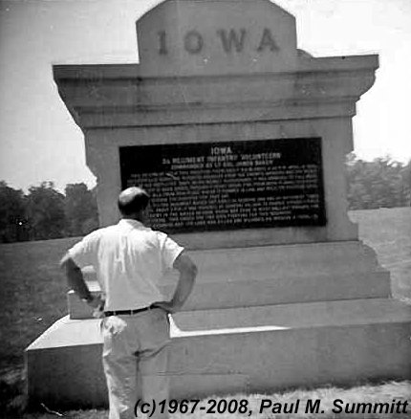Photograph 13: Chester Moody Summitt at Hornets Nest Monument Shiloh 1967
I remember we always tried to go somewhere on summer vacation. Mom and Dad took my brother and I to a large number of different historical locations. Shiloh National Battlefield, the Parthenon in Nashville, Cape Kennedy, the Grand Canyon, Custer’s Last Stand, Yellowstone National Park, the Petrified Forest, Disneyland, and the Black Hills were just some of the trips we took over those years.
We moved back to Poplar Bluff in 1967. Dad was working for the Health Department at this time. I remember taking a course that he taught on preparing for a nuclear disaster. I also remember my brother being in pictures for a burn injury program slide presentation Dad prepared. Perhaps because of that presentation, Dad got a job in Louisville, Kentucky around 1968 and we moved there. I remember Dad found Summitts in the phone directory and wanted to meet them until he discovered that they were black.
On March 10, 1970, Dad’s father, Chester Alba, passed away at the hospital in Memphis, Tennessee at the age of 83. By the summer, Dad had gotten a job in Jonesboro, Arkansas and we moved there.
Around that time, Dad joined the Elks Lodge there in Jonesboro. Mom got a job at the Elks as secretary and I got a job as busboy
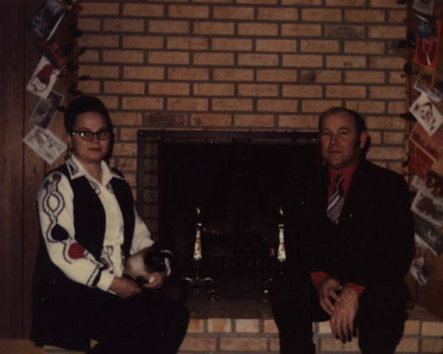
I graduated high school in 1972 and that summer moved to Austin, Texas to attend the University of Texas. During the next year and a half, things grew tense between Mom and Dad. I returned home at the end of my fall sophomore year

- 4 Nov

1974
Age 43

Death of Brother
His brother Herbert Allison died on November 4, 1974, in Jonesboro, Arkansas, when Chester Moody was 43 years old.
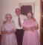

Herbert Allison SUMMITT
1912–1974

4 Nov 1974 • Jonesboro, Craighead, Arkansas, United States
- abt

1975
Age 44

Divorce
Chester Moody SUMMITT and Shirley Francis Hill were divorced in 1975 after 25 years of marriage. He was 44 years old.
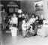

Shirley Francis Hill
1934–2012

abt 1975
- abt

1975
Age 44

Shirley Francis Frie Summitt and Chester Moody Summitt
- 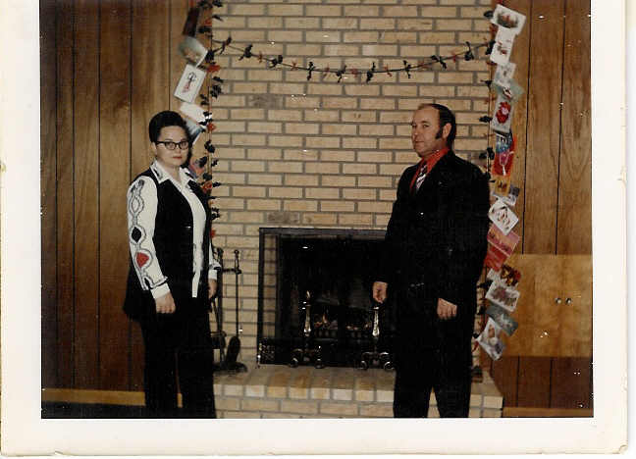

abt 1975

1977
Age 46

Chester Moody Summitt & Paul Moody Summitt 1977
- 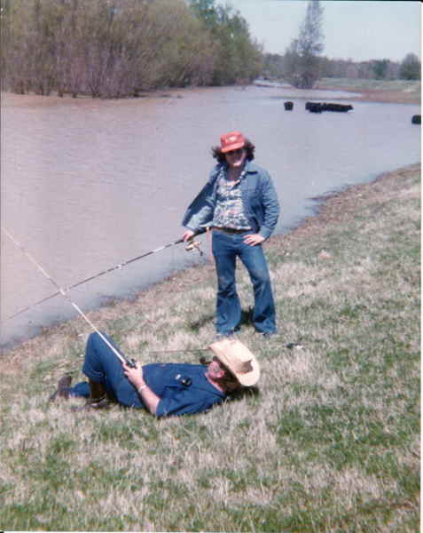

1977
- abt

1978
Age 47

Chester Moody Summitt
- 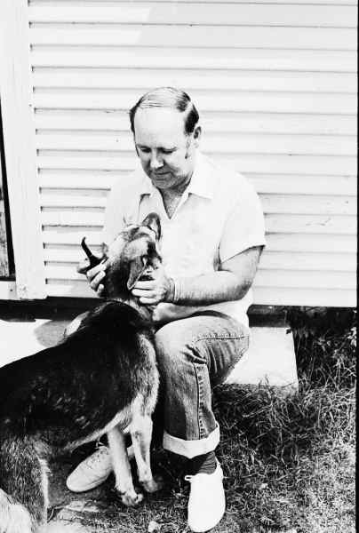

abt 1978
- abt

1978
Age 47

Dawn Lynn Mick Summitt and Chester Moody Summitt
- 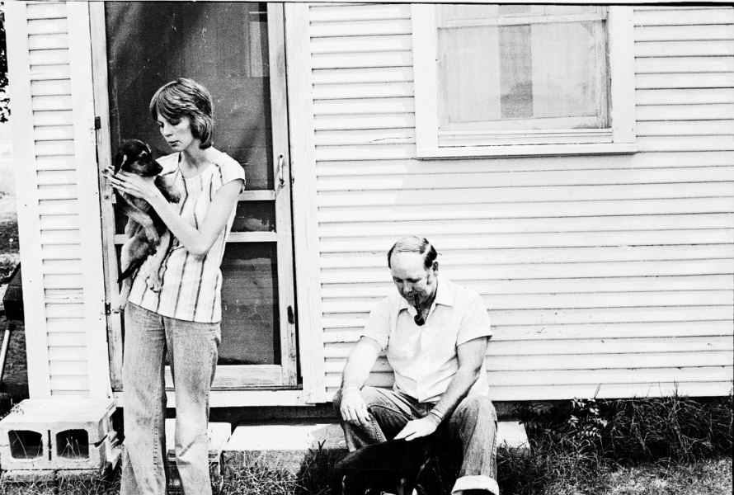

abt 1978
- abt

1978
Age 47

Chester Moody Summitt
- 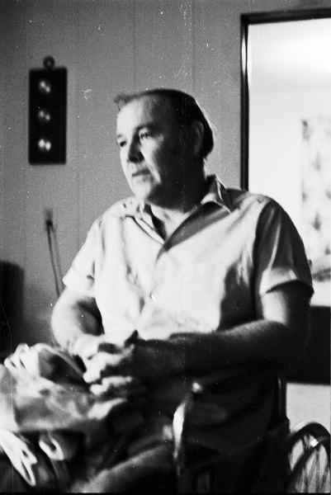

abt 1978
- Aug

1979
Age 47

Chester Moody Summitt, Paul Moody Summitt, and Paul Michael Summitt
- 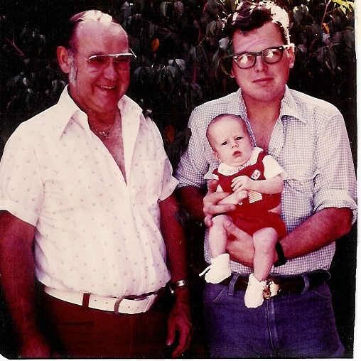

Aug 1979

1979
Age 48

Residence
Chester Moody SUMMITT lived in Cardwell, Missouri, in 1979.

1979 • Cardwell, Missouri, USA

1979
Age 48

Chester Moody Summitt & Dawn Lynn Mick Summitt & Paul Michael Summitt & Earl Holcomb
- 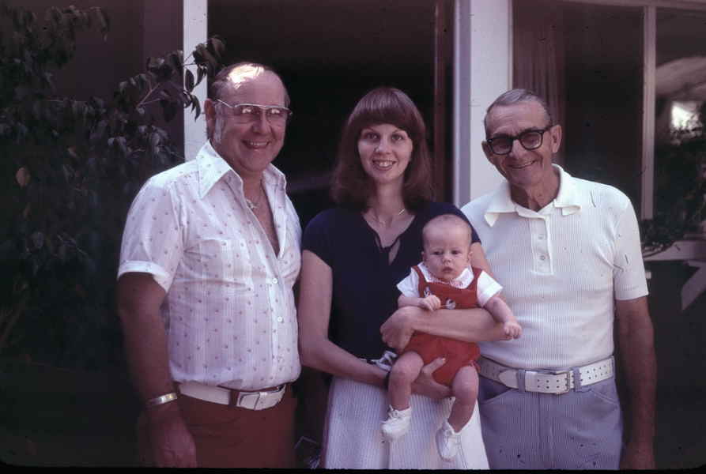

1979
- abt

1980
Age 49

Chester Moody Summitt and Paul Michael Summitt
- 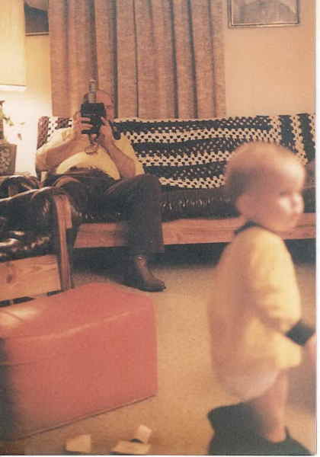

abt 1980
- abt

1980
Age 49

Chester Moody Summitt
- 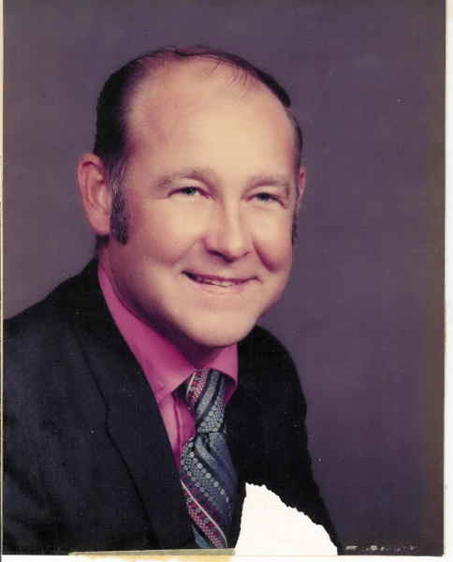

abt 1980

1985
Age 54

Chester Moody Summitt
- 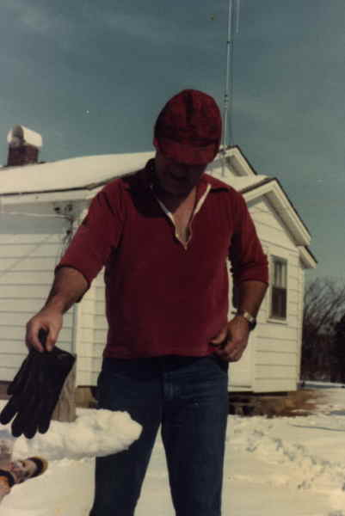

1985
- 13 May

1989
Age 57

Marriage
Chester Moody SUMMITT was married in Campbell, Missouri, on May 13, 1989, when he was 57 years old.

05/13/1989 • Campbell, Missouri
- 15 Jun

1989
Age 57

Death of Brother
His brother William Sherrill died on June 15, 1989, in Stoddard, Missouri, when Chester Moody was 57 years old.
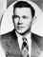

William Sherrill SUMMITT
1927–1989

15 Jun 1989 • Stoddard County, Missouri, USA
- Age 67

Residence
Chester Moody SUMMITT lived in Cardwell, Missouri.

1998 1999 2000 2001 2002 • Cardwell, Missouri

2004
Age 73

Paul Moody Summitt, Chester Moody Summitt, and Bruce Allen Summitt
- 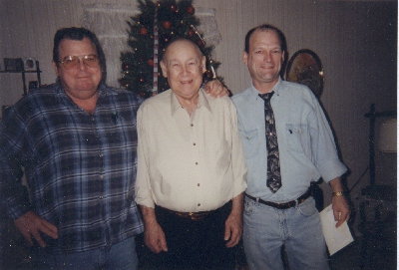

2004
- abt

2007
Age 76

Wilma Jean Cooper Summitt and Chester Moody Summitt
- 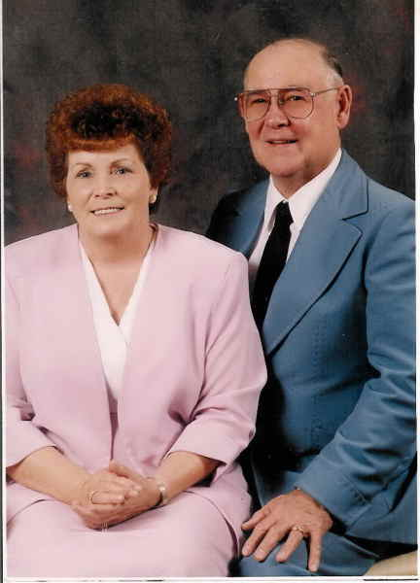

abt 2007
- Apr

2009
Age 77

Dad
- 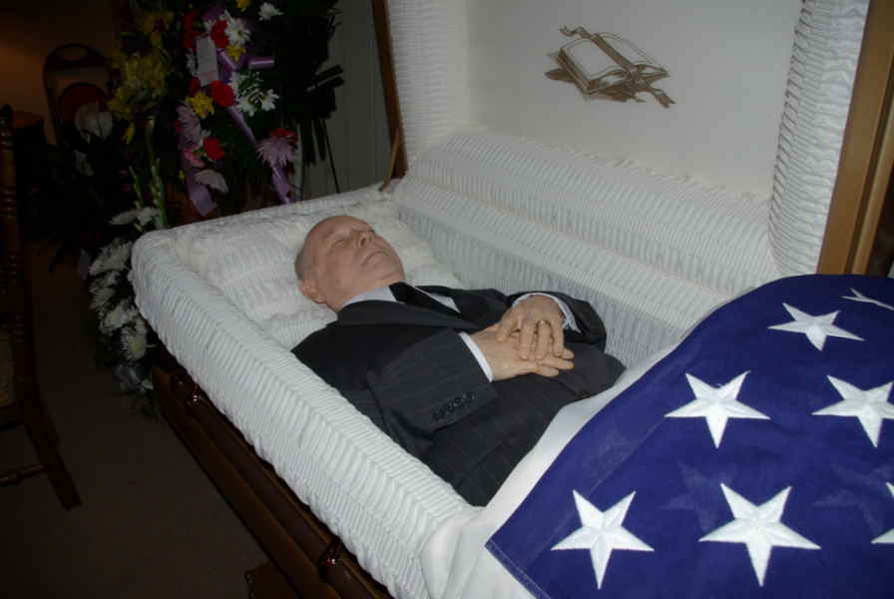

April 2009
- 27 Apr

2009
Age 77

Death
Chester Moody SUMMITT died on April 27, 2009, in Paragould, Arkansas, when he was 77 years old.

27 Apr 2009 • Paragould, Greene County, Arkansas

Burial

Cardwell, Dunklin County, Missouri, USA

